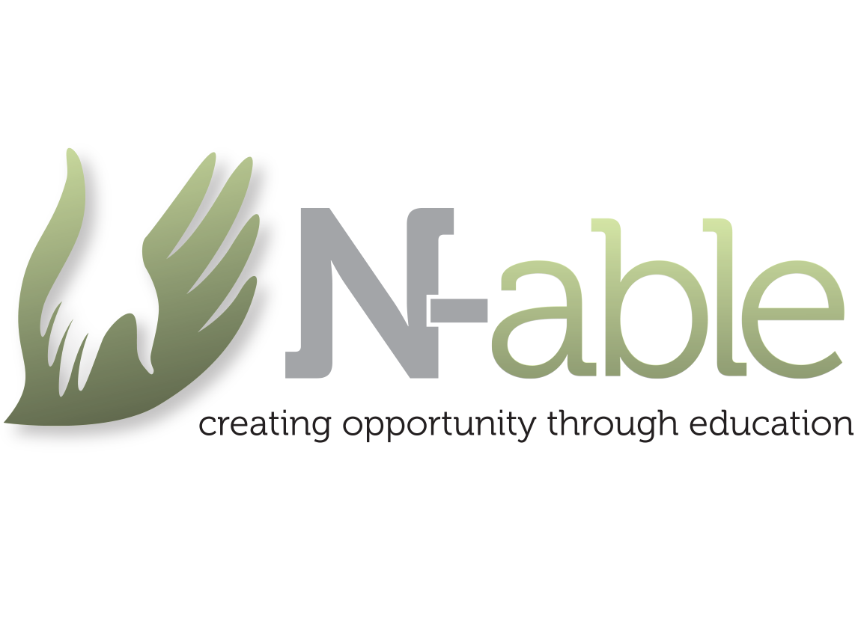
N-able Referral Process

Introduction
The N-able referral process is designed to ensure that individuals receive the right support and opportunities. This document outlines the step-by-step process to follow when making a referral.
Step 1: Identify the Need
Recognize when an individual may benefit from N-able’s programs or services.
Step 2: Gather Information
Collect relevant details about the individual, including their background, goals, and current circumstances.
Step 3: Complete Referral Form
Fill out the N-able referral form with accurate and complete information.
Step 4: Submit the Referral
Send the completed referral form to the N-able referral team via email or designated platform.
Step 5: Acknowledgement
The referral team will acknowledge receipt of the referral within 2 working days.
Step 6: Review and Assessment
The team will review the referral, assess needs, and determine appropriate support pathways.

Step 7: Feedback
Referrers will receive feedback regarding the outcome of the referral and next steps.

Name and address of contacts;
Sarah Khan, Centre Director, centredirector@n-ableworcester.co.uk
Steve Hazlehurst, Centre Manager (North), steve@n-ableworcester.co.uk
Sally Hazlehurst, Deputy Centre Manager, admin@n-ableworcester.co.uk
Claire Hailwood, Centre Manager (South), clairehailwood@-n-ableworcester.co.uk
N-able Worcester North, Attwood House, John Comyn Drive, Worcester, WR3 7NS
N-able Worcester South, Redhill House, 227 London Road, Worcester, WR5 2JG

